



Become a member now!

SIGN UP

**EVENTS & NEWS**

Notice of 2017 Annual General Meeting

Review – ACFM25th Anniversary Concert

**QUERIES**

**Artists**

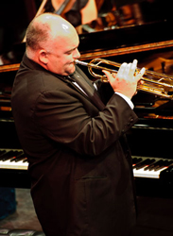

Copyright 2017

Submit

Query:

Email:

Name: